

Faculty of Engineering (Degree)
Semester – 1
Subject Name – Programming for Problem Solving
Subject Code – BE200104
Faculty Name – Ashwini Walake
Unit - 5: Arrays and searching sorting Techniques

Introduction to Array
An array in C is a fixed-size collection of similar data items.
- Items are stored in contiguous memory locations.
- Can be used to store the collection of primitive data types such as int, char, float, etc., as well as derived and user-defined data types such as pointers, structures, etc.
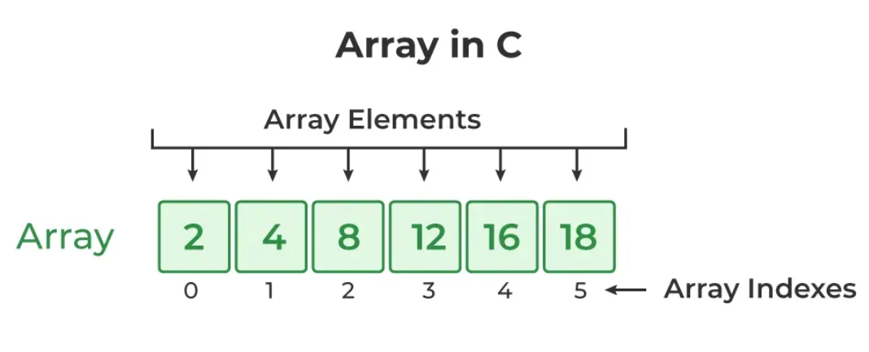
Creating an Array in C
The whole process of creating an array in C language can be divided into two primary sub processes i.e.
1. Array Declaration
Array declaration is the process of specifying the type, name, and size of the array. In C, we have to declare the array like any other variable before using it.
data_type array_name[size];
The above statements create an array with the name array_name, and it can store a specified number of elements of the same data type.
Example:
// Creates array arr to store 5 integer values.
int arr[5];
When we declare an array in C, the compiler allocates the memory block of the specified size to the array name.
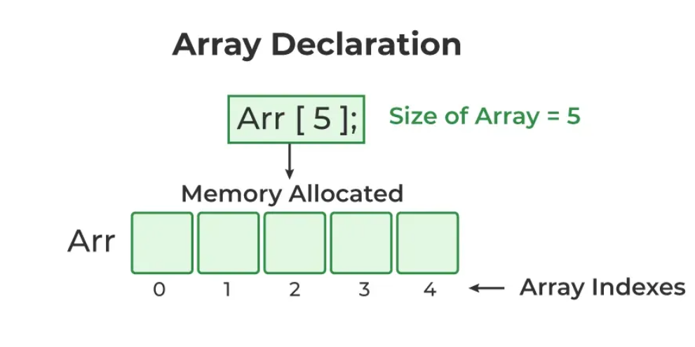
2. Array Initialization
Initialization in C is the process to assign some initial value to the variable. When the array is declared or allocated memory, the elements of the array contain some garbage value. So, we need to initialize the array to some meaningful values.
Syntax:
int arr[5] = {2, 4, 8, 12, 16};
The above statement creates an array arr and assigns the values {2, 4, 8, 12, 16} at the time of declaration.
We can skip mentioning the size of the array if declaration and initialisation are done at the same time. This will create an array of size n where n is the number of elements defined during array initialisation. We can also partially initialize the array. In this case, the remaining elements will be assigned the value 0 (or equivalent according to the type).
//Partial Initialisation
int arr[5] = {2, 4, 8};

//Skiping the size of the array.
int arr[] = {2, 4, 8, 12, 16};

//initialize an array with all elements set to 0.
int arr[5] = {0};
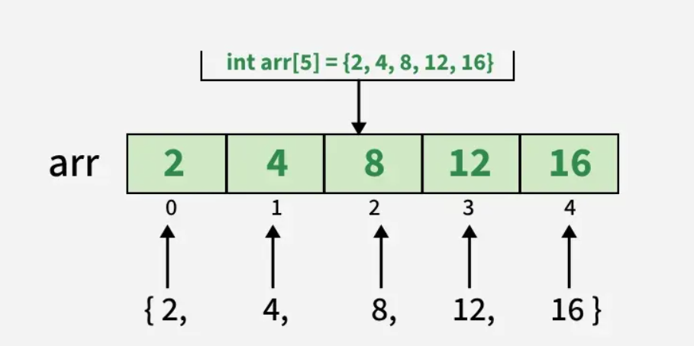
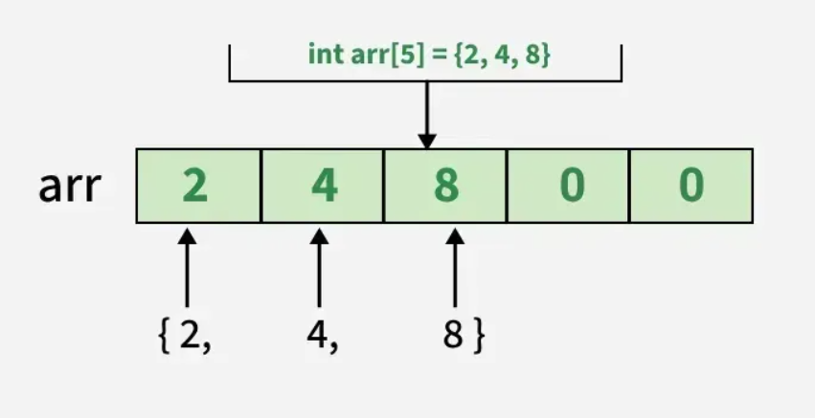
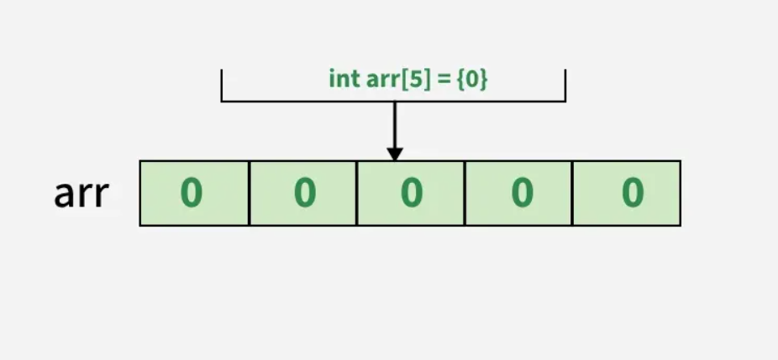
Accessing Array Elements
Array in C provides random access to its elements, which means that we can access any element of the array by providing the position of the element, called the index.
Syntax:
The index values start from 0 and goes up to array_size-1. We pass the index inside square brackets [] with the name of the array.
array_name [index];
where, index value lies into this range - (0 ≤ index ≤ size-1).
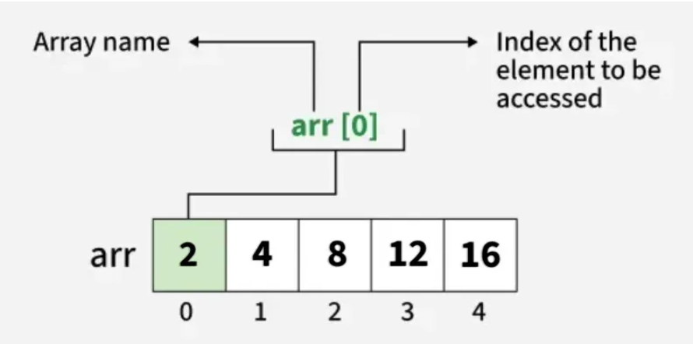
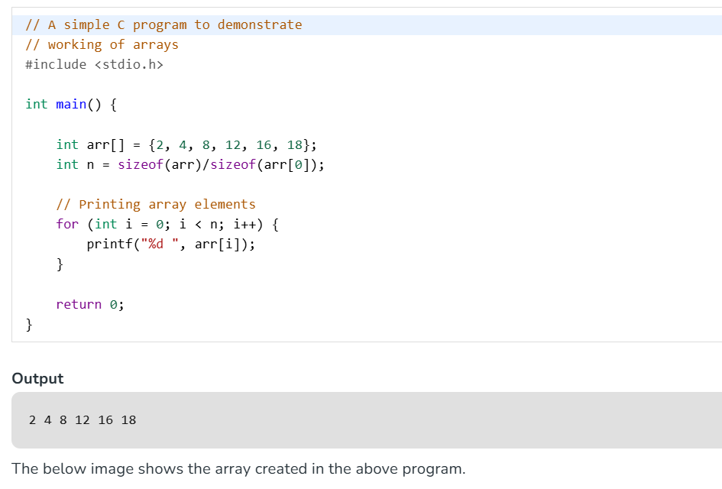
Types of Array
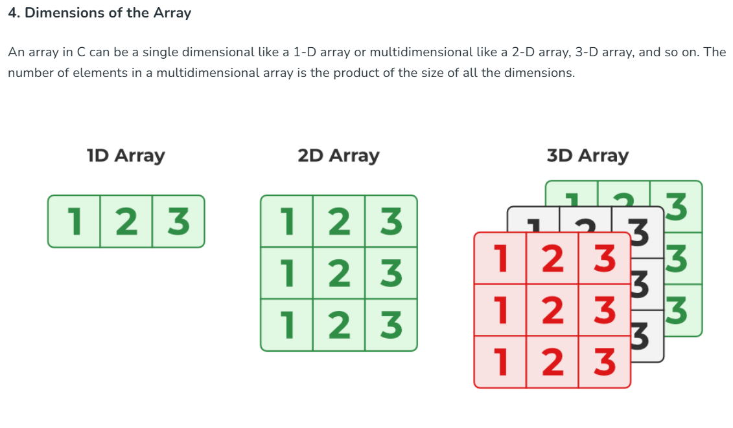
2D Arrays in C
A two-dimensional array or 2D array is the simplest form of the multidimensional array. We can visualize a two-dimensional array as one-dimensional arrays stacked vertically forming a table with 'm' rows and 'n' columns. In C, arrays are 0-indexed, so the row number ranges from 0 to (m-1) and the column number ranges from 0 to (n-1).

Declaration of 2D Array
A 2D array with m rows and n columns can be created as:
type arr_name[m][n];
For example, we can declare a two-dimensional integer array with name 'arr' with 10 rows and 20 columns as:
int arr[10][20];

Initialization of 2D Arrays
We can initialize a 2D array by using a list of values enclosed inside '{ }' and separated by a comma as shown in the example below:
int arr[3][4] = {0, 1 ,2 ,3 ,4 , 5 , 6 , 7 , 8 , 9 , 10 , 11};
or
int arr[3][4] = {{0, 1, 2, 3}, {4, 5, 6, 7}, {8, 9, 10, 11}};
The elements will be stored in the array from left to right and top to bottom. So, the first 4 elements from the left will be filled in the first row, the next 4 elements in the second row, and so on. This is clearly shown in the second syntax where each set of inner braces represents one row.
In list initialization, we can skip specifying the size of the row. The compiler will automatically deduce it in this case. So, the below declaration is valid.type arr_name[][n] = {...values...};
It is still compulsory to define the number of columns.
Accessing Elements
An element in two-dimensional array is accessed using row indexes and column indexes inside array subscript operator [].
arr_name[i][j]

Multi-dimensional arrays in C are arrays that grow in multiple directions or dimensions. A one-dimensional array grows linearly, like parallel to the X-axis, while in a multi-dimensional array, such as a two-dimensional array, the elements can grow along both the X and Y axes.
Syntax
type array_name[size1][size2] .. [sizen];
Some commonly used multidimensional arrays are:
- Two-Dimensional Array: It is an array that has exactly two dimensions. It can be visualized in the form of rows and columns organized in a two-dimensional plane.
- Three-Dimensional Array: A 3D array has exactly three dimensions. It can be visualized as a collection of 2D arrays stacked on top of each other to create the third dimension.
Size of Multidimensional Arrays
The total number of elements that can be stored in a multidimensional array can be calculated by multiplying the size of both dimensions. Consider the array arr[10][20]:
- The array int arr[10][20] can store total of (10*20) = 200 elements.
To get the size in bytes, we multiply the size of a single element (in bytes) by the total number of elements in the array.
- The size of array int arr[10][20] = 10 * 20 * 4 = 800 bytes, where the size of int is 4 bytes.

Operations
The operations of an array include −
- Searching − It is used to find whether particular element is present or not.
- Sorting − Helps in arranging the elements in an array either in an ascending or descending order.
- Traversing − Processing every element in an array, sequentially.
- Inserting − Helps in inserting elements in an array.
- Deleting − Helps in deleting the element in an array.
Example of Searching element of array
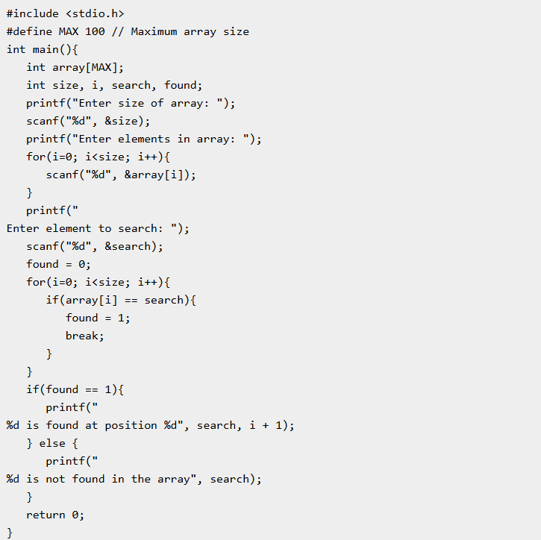
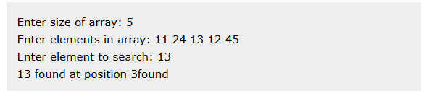

Searching array
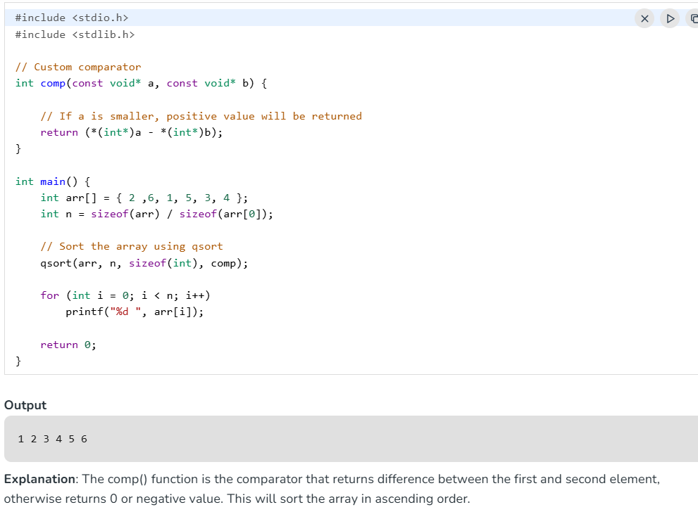

Characteristic of an Array Element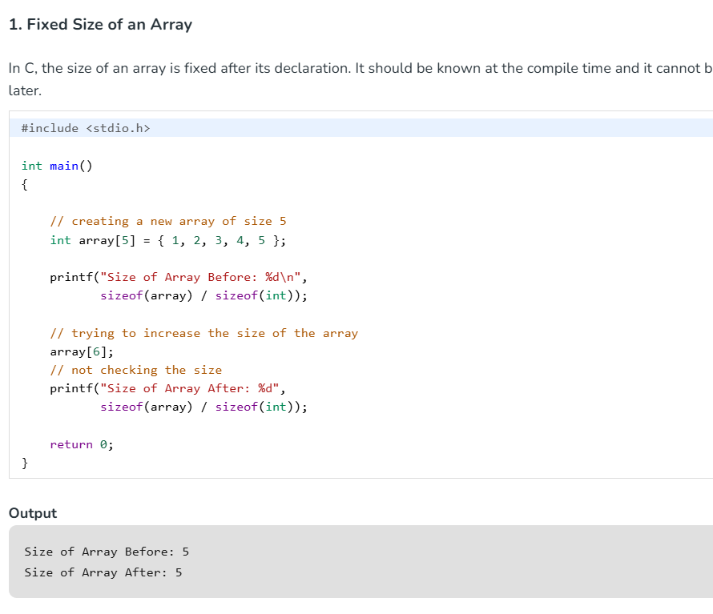
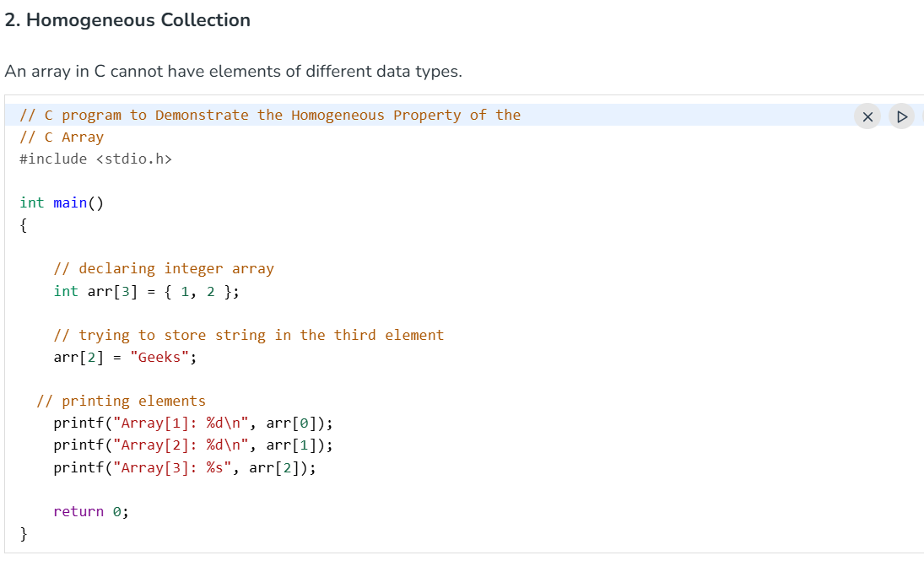
Arrays can only store elements of the same data type.
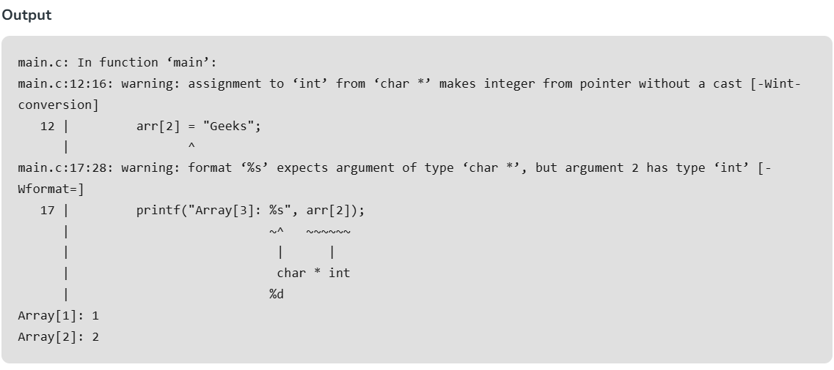
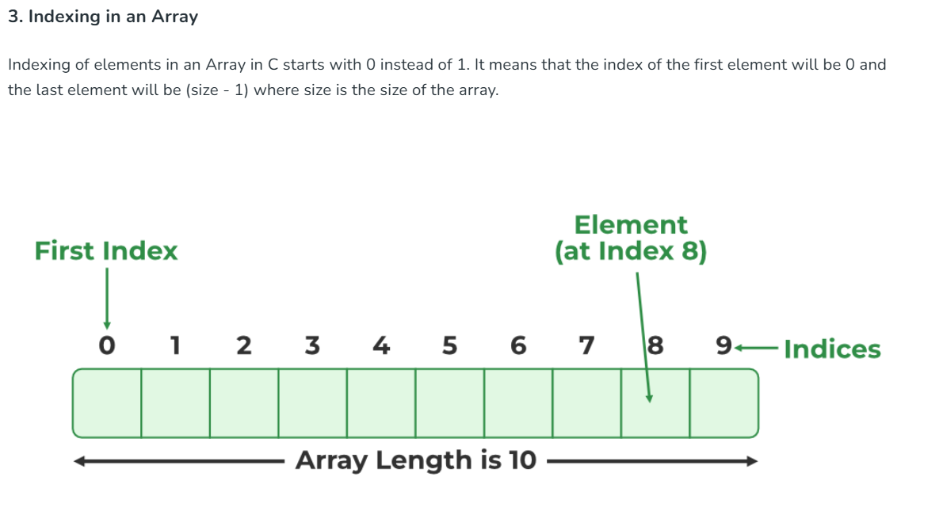
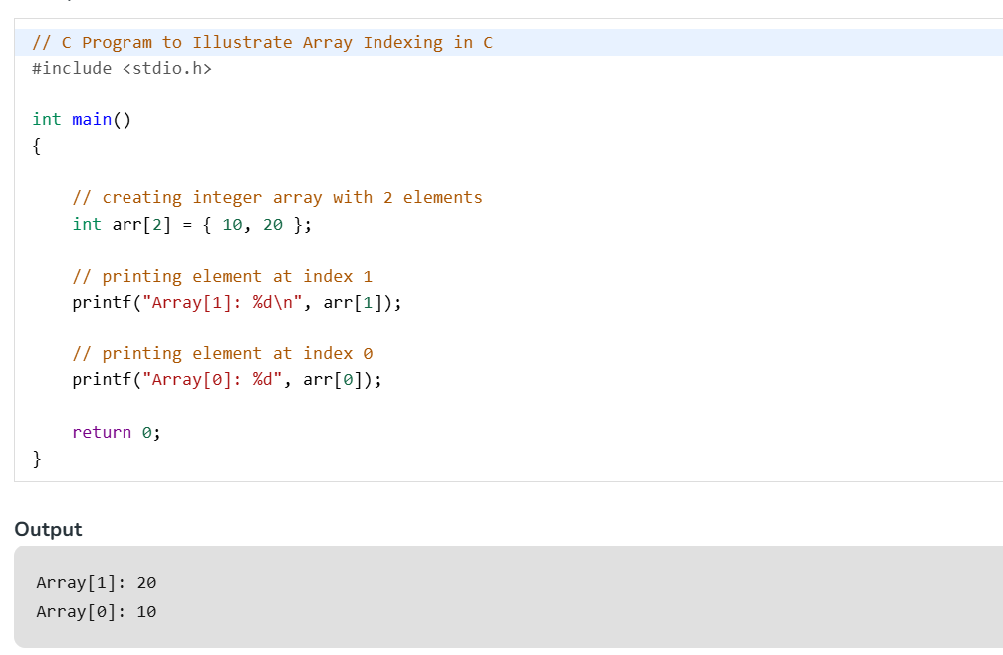
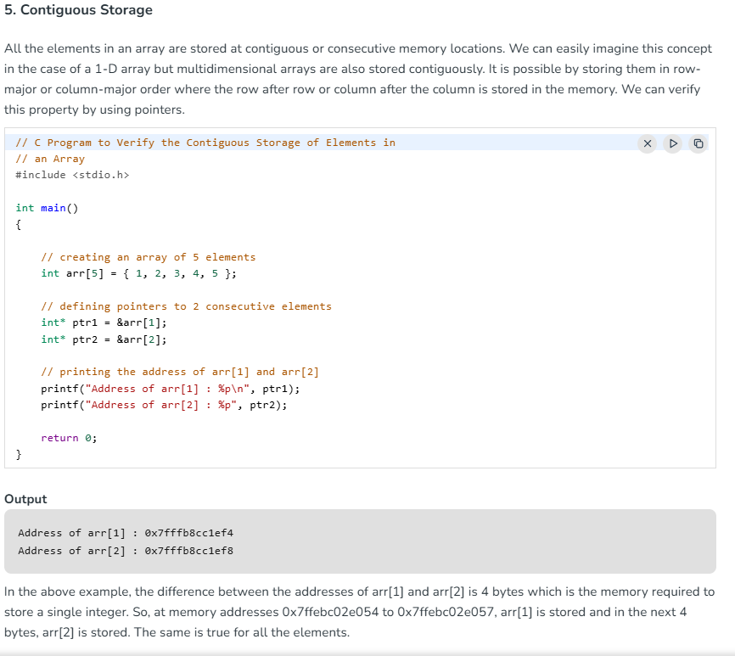
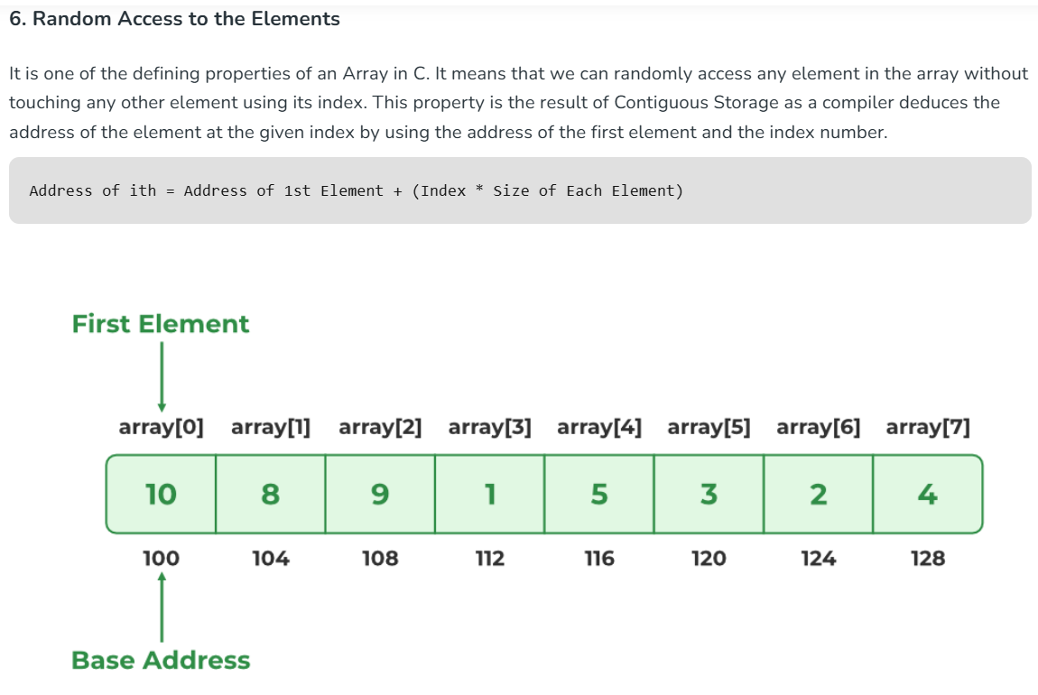
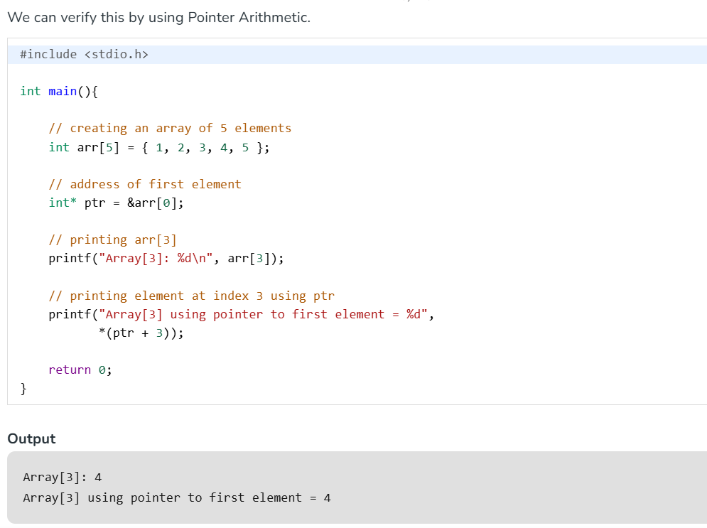

Advantages of Array in C
The following are the main advantages of an array:
- Random and fast access of elements using the array index.
- Use of fewer lines of code as it creates a single array of multiple elements.
- Traversal through the array becomes easy using a single loop.
- Sorting becomes easy as it can be accomplished by writing fewer lines of code.
Disadvantages of Array in C
- C Arrays are not dynamic they only allow a fixed number of elements to be entered which is decided at the time of declaration.
- Insertion and deletion of elements can be costly since the elements are needed to be rearranged after insertion and deletion.

